**Name:** Vishal Shashikant Salvi.

**Class**: SE Comps

**Batch:** C

**UID: 2019230069**

**Experiment No 4**

**Aim:**

To create a product order form using Javascript and the JQuery library with some basic functionalities implemented using JQuery.

**Theory:**

**What is jQuery?**

jQuery is a lightweight, "write less, do more", JavaScript library.

The purpose of jQuery is to make it much easier to use JavaScript on your website.

jQuery takes a lot of common tasks that require many lines of JavaScript code to accomplish, and wraps them into methods that you can call with a single line of code.

jQuery also simplifies a lot of the complicated things from JavaScript, like AJAX calls and DOM manipulation.

jQuery is a fast, small, and feature-rich JavaScript library. It makes things like HTML document traversal and manipulation, event handling, animation, and Ajax much simpler with an easy-to-use API that works across a multitude of browsers. With a combination of versatility and extensibility, jQuery has changed the way that millions of people write JavaScript.

The jQuery library contains the following features:

* HTML/DOM manipulation
* CSS manipulation
* HTML event methods
* Effects and animations
* AJAX
* Utilities

## How to use jQuery?

There are two ways to use jQuery.

* **Local Installation** − You can download jQuery library on your local machine and include it in your HTML code.
* **CDN Based Version** − You can include jQuery library into your HTML code directly from Content Delivery Network (CDN).

## Local Installation

* Go to the <https://jquery.com/download/> to download the latest version available.
* Now put downloaded **jquery-2.1.3.min.js** file in a directory of your website, e.g. /jquery.

### **Example**

Now you can include *jquery* library in your HTML file as follows −

<html>

<head>

<title>The jQuery Example</title>

<script type = "text/javascript" src = "/jquery/jquery-2.1.3.min.js">

</script>

<script type = "text/javascript">

$(document).ready(function() {

document.write("Hello, World!");

});

</script>

</head>

<body>

<h1>Hello</h1>

</body>

</html>

**This will produce following result −**

## Hello,World!

**jQuery Important Features**

* DOM Selection: jQuery provides Selectors to retrieve DOM element based on different criteria like tag name, id, css class name, attribute name, value, nth child in hierarchy etc.
* DOM Manipulation: You can manipulate DOM elements using various built-in jQuery functions. For example, adding or removing elements, modifying html content, css class etc.
* Special Effects: You can apply special effects to DOM elements like show or hide elements, fade-in or fade-out of visibility, sliding effect, animation etc.
* Events: jQuery library includes functions which are equivalent to DOM events like click, dblclick, mouseenter, mouseleave, blur, keyup, keydown etc. These functions automatically handle cross-browser issues.
* Ajax: jQuery also includes easy to use AJAX functions to load data from servers without reloading whole page.
* Cross-browser support: jQuery library automatically handles cross-browser issues, so the user does not have to worry about it. jQuery supports IE 6.0+, FF 2.0+, Safari 3.0+, Chrome and Opera 9.0+.

**Advantages of jQuery**

* Easy to learn: jQuery is easy to learn because it supports same JavaScript style coding.
* Write less do more: jQuery provides a rich set of features that increase developers' productivity by writing less and readable code.
* Excellent API Documentation: jQuery provides excellent online API documentation.
* Cross-browser support: jQuery provides excellent cross-browser support without writing extra code.
* Unobtrusive: jQuery is unobtrusive which allows separation of concerns by separating html and jQuery code.

## Code:

## Jquery.html

<!DOCTYPE html>

<html lang="en">

<head></head>

<meta name="viewport" content="width=device-width,initial-scale=1.0" charset="UTF-8"> <title>Online Book Order</title>

 <script src="https://ajax.googleapis.com/ajax/libs/jquery/3.4.1/jquery.min.js"></script>

</head>

<body>

<script>

$(document).ready(function() {

'use strict';

//  setting the focus to first input element $("#focusable").focus();

//  showing labels on focus

$(".custom-input .input").on('blur', function()

{

if ($(this).val() !== '') {

$(this).parent().addClass('filled');

}

else {

$(this).parent().removeClass('filled');

}

});

//  setting the background color of the element

$(".input").focus(function()

{ $(this).css({"background-color":"#ffffb7"}) });

$(".input").blur(function() {

$(this).css({"background":"transparent"})

});

//  detecting the key pressed on the keyboard

$(".input").keypress(function(e){

    console.log(e.keyCode || e.which);

});

$("#response input").on('change', function() {

if ($("[type='radio']:checked").val() === 'yes') {

 $("#shippingaddress").hide();

} else {

$("#shippingaddress").show();

}

});

//  getting the checked or selected items

$(".selected-items input").on('change', function() {

    if (this.checked) {

var getCheckBoxes = $('input[name=product]');

getCheckBoxes.each(function() {

if (!$(this).is(':checked')) {

$("." + $(this).val()).hide();

}

});

} else {

var getCheckBoxes = $('input[name=product]'); getCheckBoxes.each(function() {

$("." + $(this).val()).show();

});

}

});

//  fade toggling a product explanation div and other mouse events

$("img").on('click', function() {

$("." + $(this).attr('alt') + "-exp").fadeToggle(500);

$("." + $(this).attr('alt') + "-exp p").on('mouseenter',function() {

$(this).css('background-color', 'Lightgreen');

var words = $(this).first().text().split( /\s+/ );

var text = words.join( "</span> <span>" );

$(this).first().html( "<span>" + text + "</span>" );

$( "span" ).on( "click", function() {

$(this).css( "background-color", "#ffddc3"

);

});

}).on('mouseleave', function() {

$(this).css('background', 'transparent');

});

});

$(".btn").on('click', function() {

    alert('Your Order is Successful!!');

});

});

</script>

<style>

@import url('https://fonts.googleapis.com/css?family=Josefin+Sans&display=swap');

*{

margin: 0;

padding: 0;

box-sizing: border-box;

font-family:    sans-serif;

}

.product-details img {

margin: 5px 0 5px 0;

float: left;

border: 1px solid #000000;

border-radius: 10px;

}

img:hover {

transform: scale(1.1);

cursor: pointer;

}

input {

margin: 7px 0 7px 7px;

}

#shippingaddress {

display: none;

}

.product-details label {

font-size: large;

margin-left: 1%;

}

body{

background-image: url("Library.jpg");

background-attachment: fixed;

background-repeat: no-repeat;

background-size: 100% 100%;

height: 100vh;

}

.header {

font-size: 5rem;

border-bottom: 2px solid black;

padding: 0 10px 5px;

color:red;

font-family: "Comic Sans MS", cursive, sans-serif;

text-align: center;

}

#side-to-side {

display: flex;

}

.wrapper{

margin: 1% 0 1% 0;

position: absolute;

width: 100%;

padding: 0 20px;

}

.contact-form{

max-width: 1000px;

margin: 0 auto;

background: cyan;

padding: 30px;

border-radius: 15px;

box-shadow: 0 0 10px #f4f3ef;

}

.custom-input {

position: relative;

}

.custom-input input:focus {

outline: 0;

}

.custom-input input + label {

position: absolute;

top: 30px;

left: 10px;

color: #dc1c13;

opacity: 0.5;

transition: .5s;

}

.custom-input input:focus + label,

.filled input + label {

top: 0;

left: 0;

font-size: 18px;

color: #dc1c13;

opacity: 1;

}

.input-fields,

 .formalities{

width: 50%;

}

.input,

.custom-input .input,

.formalities textarea{

margin: 20px 0;

background: transparent;

padding: 10px;

color: #dc1c13;

border: 1px solid black;

margin-right: 2%;

border-radius: 4px;

font-size: 15px;

}

.btn {

background: #57e86b;

text-align: center;

padding: 15px;

border-radius: 5px;

color: #fff;

cursor: pointer;

text-transform: uppercase;

}

::-webkit-input-placeholder {

/* Chrome/Opera/Safari */

color: #dc1c13;

opacity: 0.5;

}

@media screen and (max-width: 600px){

.contact-form{

flex-direction: column;

}

.formalities textarea{

height: 80px;

}

.input-fields,

.formalities{

width: 100%;

}

}

</style>

<div class="wrapper">

<div class="contact-form">

<div class="header">Order Books online</div>

<div class="input-fields">

<br>

<text style="font-size: large;color: #dc1c13;float: left;">Our Best Sellers</text> <div class="selected-items" style="float: right;">

<input type="checkbox" id="check">

 <label for="check" style="color:#dc1c13;"> Show selected items </label>

</div>

<br><br>

<div style="color: #dc1c13;"class="product-details">

<div class="Idali" style="padding: 3px;">

<img title="Click to toggle description" src="Idali.jpg" alt="Idali" width="80px" height="80px">

<input type="checkbox" id="product1" name="product" value="Idali">

<label for="product"> Idali Orchid and Will power <b>₹ 400</b></label><br>

<div style="padding: 15px;"></div>

<label  for="qty">Quantity </label>

<select>

<option value="1"selected>1</option>

<option value="2">2</option>

<option value="3">3</option>

<option value="4">4</option>

<option value="5">5</option>

<option value="6">6</option>

<option value="7">7</option>

<option value="8">8</option>

<option value="9">9</option>

<option value="10">10</option>

</select>

<div class="Idali-exp "style="display: none;">

<br>

<p style="border: 1.5px solid lightgrey; border-radius: 3px; padding: 5px">

An Autobiography of a successful entrepreneur & his inspiring experiences shared since commencement of a small hotel to a five starer hotel Orchid.

</p>

</div>

</div>

<br>

<div class="Yayati" style="padding: 3px;">

<img title="Click to toggle description" src="Yayati.jpg" alt="Yayati" width="80px"height="80px">

<input type="checkbox" id="product2" name="product" value="Yayati"> <label for="product"> Yayati<b>₹ 525</b></label><br>

<div style="padding: 15px;"></div>

<label for="qty">Quantity </label>

<select>

<option value="1"selected>1</option>

<option value="2">2</option>

 <option value="3">3</option>

<option value="4">4</option>

<option value="5">5</option>

<option value="6">6</option>

<option value="7">7</option>

<option value="8">8</option>

<option value="9">9</option>

<option value="10">10</option>

</select>

<div class="Yayati-exp"style="display: none;">

<br>

<p style="border: 1.5px solid lightgrey; border-radius: 3px; padding: 5px">The story of Yayati is perhaps one of the most intriguing and fascinating episodes of Mahabharata. Yayati was a great scholar and one of the noblest rulers of olden times. He followed the shastras and was devoted to the welfare of his subjects. Even the King of Gods, Indra, held him in high esteem. Married to seductively beautiful Devyani, in love with her maid Sharmishtha, and father of five sons from two women, yet Yayati unabashedly declares, My lust for pleasure is unsatisfied. His quest for the carnal continued, sparing not even his youngest son, and exchanging his old age for his son s youth. </p>

</div>

</div>

<br>

<div class="Mrutyunjay" style="padding: 3px;">

<img title="Click to toggle description" src="Mrutunjay.jpg " alt="Mrutyunjay" width="80px" height="80px">

<input type="checkbox" id="product3"name="product" value="Mrutyunjay">

<label for="product"> Mrutyunjay <b>₹ 200</b></label><br>

<div style="padding: 15px;"></div>

<label for="qty">Quantity </label>

<select>

<option value="1"selected>1</option>

<option value="2">2</option>

<option value="3">3</option>

<option value="4">4</option>

<option value="5">5</option>

<option value="6">6</option>

<option value="7">7</option>

<option value="8">8</option>

<option value="9">9</option>

<option value="10">10</option>

</select>

<div class="Mrutyunjay-exp"style="display: none;">

<br>

<p style="border: 1.5px solid lightgrey; border-radius: 3px; padding: 5px">

    The search for the meaning of Being is man's eternal quest and the subject of his greatest creations. Shivaji Sawant's Mrityunjaya is an outstanding instance of such a literary masterpiece in which a contemporary Marathi novelist investigates the meaning of the bewildering skein that is life through the personae of the Mahabharata protagonists. For over two decades since its first publication the vast non- Marathi and non-Hindi readership remained deprived of this remarkable exploration of the human psyche till the publication of this English translation by the Writers workshop – a contribution for which there is much to be grateful for.</p>

</div>

</div>

<br>

 <div class="Shyamchi Aai" style="padding: 3px;">

<img title="Click to toggle description" src="Shyamchi Aai.jpg " alt="Shyamchi Aai" width="80px" height="80px">

<input type="checkbox" id="product3"name="product" value="Shyamchi Aai">

<label for="product"> Shyamchi Aai <b>₹ 350</b></label><br>

    <div style="padding: 15px;"></div>

    <label for="qty">Quantity </label>

    <select>

    <option value="1"selected>1</option>

    <option value="2">2</option>

    <option value="3">3</option>

    <option value="4">4</option>

    <option value="5">5</option>

    <option value="6">6</option>

    <option value="7">7</option>

    <option value="8">8</option>

    <option value="9">9</option>

    <option value="10">10</option>

    </select>

    <div class="Shyamchi Aai-exp"style="display: none;">

    <br>

    <p style="border: 1.5px solid lightgrey; border-radius: 3px; padding: 5px">

        Shyamchi Aai is considered an iconic piece of work in Marathi literature even after so many decades, and reasonably so. It beautifully depicts how the greatness of a mother's love and her moral upbringing moulds her children - especially Shyam, who supposedly is the great author Sane Guruji himself as a teenager - into fine human beings.</p>

</div>

</div>

<br>

    <div class="Yugandhar" style="padding: 3px;">

        <img title="Click to toggle description" src="Yugandhar.jpeg " alt="Yugandhar" width="80px" height="80px">

        <input type="checkbox" id="product3"name="product" value="Yugandhar">

        <label for="product"> Yugandhar <b>₹ 250</b></label><br>

        <div style="padding: 15px;"></div>

        <label for="qty">Quantity </label>

        <select>

        <option value="1"selected>1</option>

        <option value="2">2</option>

        <option value="3">3</option>

        <option value="4">4</option>

        <option value="5">5</option>

        <option value="6">6</option>

        <option value="7">7</option>

        <option value="8">8</option>

        <option value="9">9</option>

        <option value="10">10</option>

        </select>

        <div class="Yugandhar-exp"style="display: none;">

        <br>

        <p style="border: 1.5px solid lightgrey; border-radius: 3px; padding: 5px">

            Yugandhar- is a brilliant piece of work from Shivaji Sawant. Author tries hard to contain the protagonist within human sphere but also surrenders to the divinity at appropriate places. Immense detailing takes the reader into that era. It is a long long piece of text but something worth having and passing onto generations.        </p>

        </div>

        </div>

        <br>

</div>

<div id="side-to-side">

<div class="custom-input"style="margin-right: 2%;">

<input id="focusable"type="text" class="input" name="firstname" value="">

<label for="">First Name</label>

</div>

<div class="custom-input">

<input type="text"class="input" name="lastname" value="">

<label for="">Last Name</label>

</div>

</div>

<div class="custom-input">

<input style="width: 85%;"type="text" name="email" value="" class="input"> <label for="">Email</label> </div>

<div id="side-to-side">

<div class="custom-input">

<input style="width:65px;"type="text" class="input" name="code" value=""> <label for="">Code</label>

</div>

<text style="padding: 28px 10px 010px; color: #fff;">- </text>

<div class="custom-input">

<input type="text"class="input" name="phonenumber" value="">

<label for="">Phone Number</label>

</div>

</div>

</div>

<div class="formalities">

<br>

<label for="" style="color: #dc1c13;font-size: larger;">Billing Address</label>

<textarea class="input" rows="2" cols="60"placeholder="Enter your address here..."></textarea>

<div id="side-to-side">

<div class="custom-input"style="margin-right: 2%;">

<input type="text"class="input" name="city" value="">

<label for="">City</label>

</div>

<div class="custom-input">

<input type="text"class="input" name="place" value="">

<label for="">State /Province</label>

</div>

</div>

<div id="side-to-side">

<div class="custom-input">

<input style="width: 180px;"type="text" class="input" name="zipcode" value=""> <label for="">Postal / ZipCode</label>

</div>

<select style="width: 350px;margin-left: 2%; background-color: #f4f3ef;" id="country"name="country" class="input">

<option value="Select">--Select Country --</option>

<option value="India">India</option>

<option value="Australia">Australia</option>

<option value="Germany">Germany</option>

<option value="USA">USA</option>

</select>

</div>

<br>

<text style="color: #dc1c13;">Is the shipping address same as billing address?</text><br><br> <span id="response">

<input type="radio" name="residence"value="yes">

<label for="yes" style="color:#dc1c13; padding-right: 20px;"> Yes</label>

<input type="radio" name="residence"value="no">

<label for="no" style="color:#dc1c13;"> No</label>

</span>

<br><br>

<div id="shippingaddress">

<label for="" style="color: #dc1c13;font-size: larger;">Shipping Address</label>

<textarea class="input" rows="2"cols="60" placeholder="Enter your address here..."></textarea>

<div id="side-to-side">

<div class="custom-input"style="margin-right: 2%;">

<input type="text"class="input" name="city" value="">

<label for="">City</label>

</div>

<div class="custom-input">

<input type="text"class="input" name="place" value="">

<label for="">State</label>

</div>

</div>

<div id="side-to-side">

<div class="custom-input">

<input style="width:180px;" type="text" class="input" name="zipcode" value="">

<label for="">Postal /Zip Code</label>

</div>

<select style="width: 350px;margin-left: 2%; background-color: #f4f3ef;" id="country"name="country" class="input">

<option value="Select">--Select Country --</option>

<option value="India">India</option>

<option value="Australia">Australia</option>

<option value="Germany">Germany</option>

<option value="USA">USA</option>

</select>

</div>

<br>

</div>

<text style="color: #dc1c13;">Send gift?</text><br><br>

<input type="radio" name="gift"value="yes">

<label for="yes" style="color: #dc1c13;padding-right: 20px;"> Yes</label>

<input type="radio" name="gift"value="no">

<label for="no" style="color: #dc1c13;">No</label>

<br><br>

<label for="" style="color: #dc1c13; font-size: larger;">Special Instructions</label> <textarea class="input" rows="4" cols="45" placeholder="Any special instructions..."></textarea> </div>

<div class="btn" >Order Now !</div>

</div>

</div>

 </body>

**Output**:

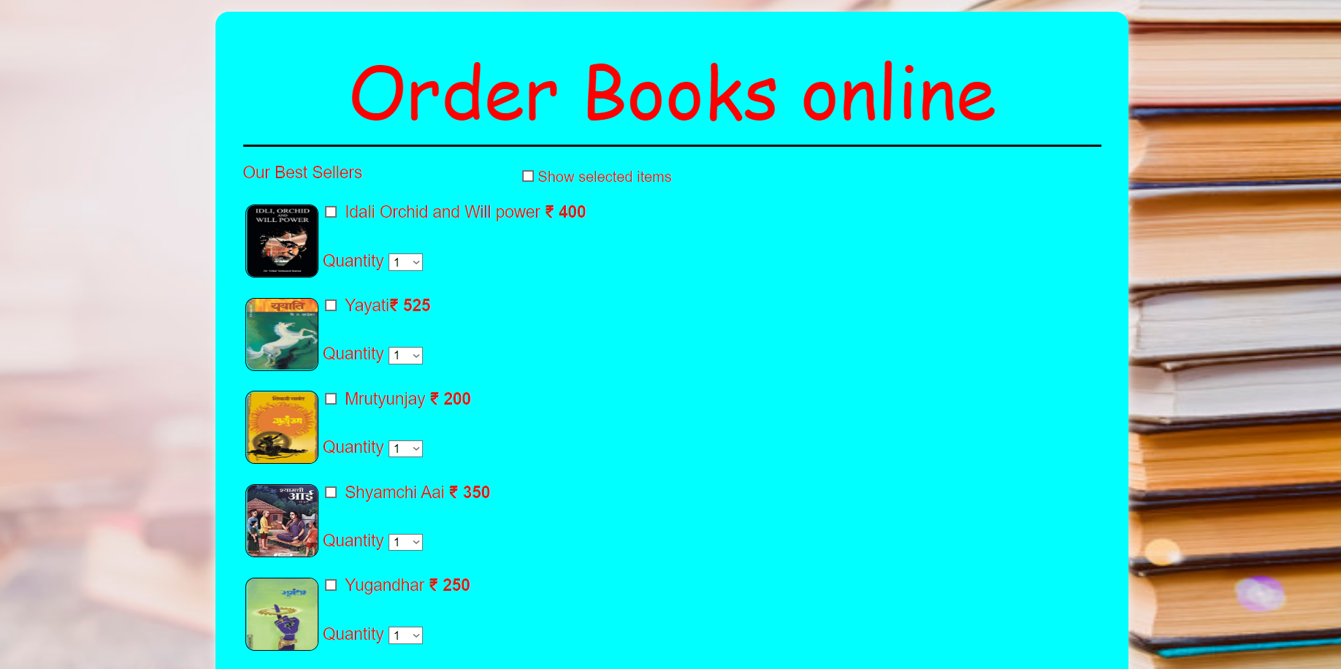





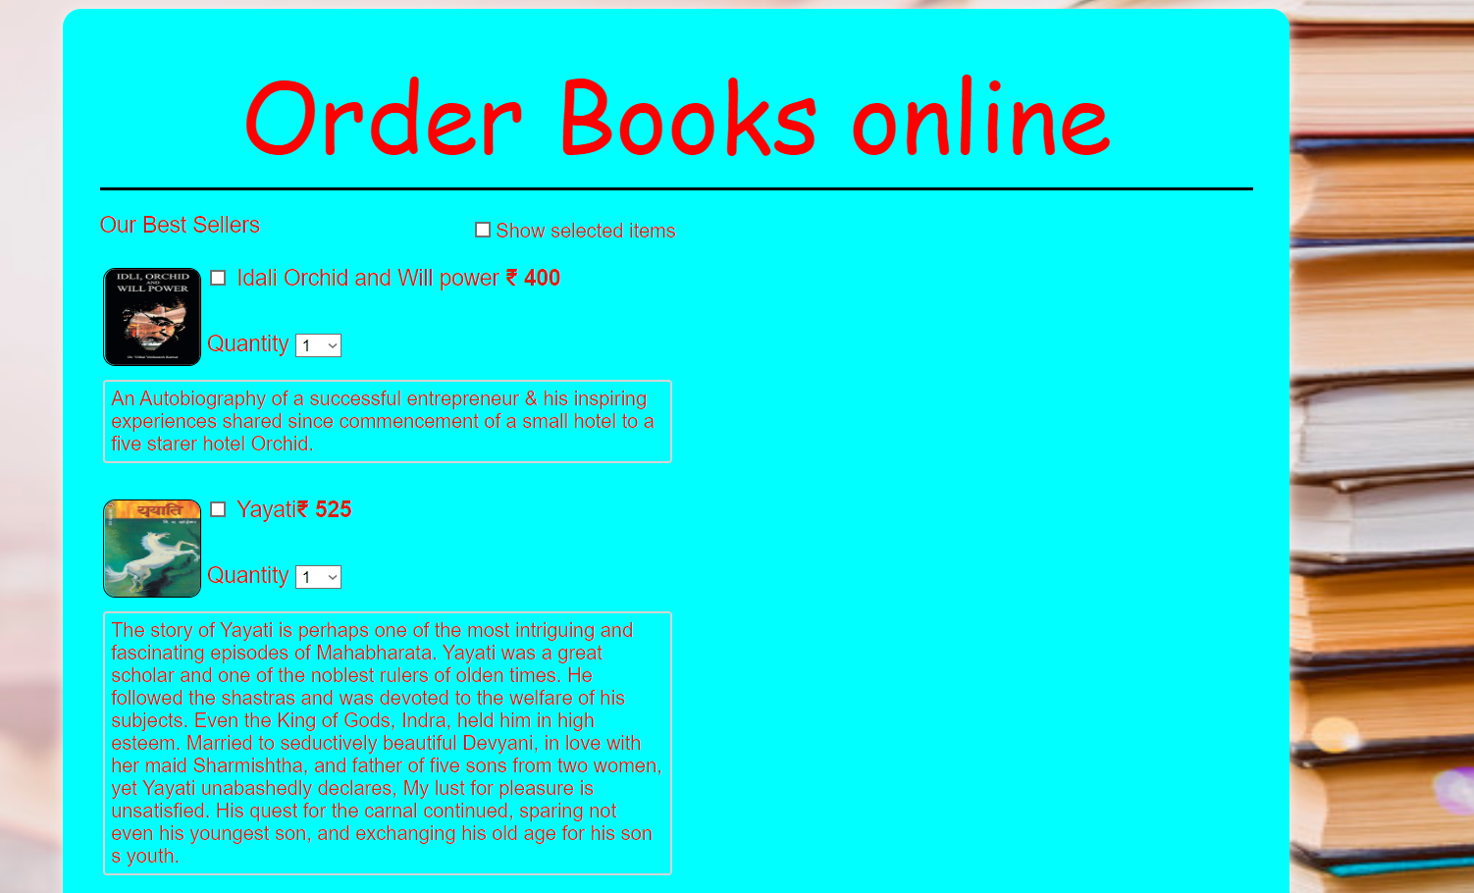



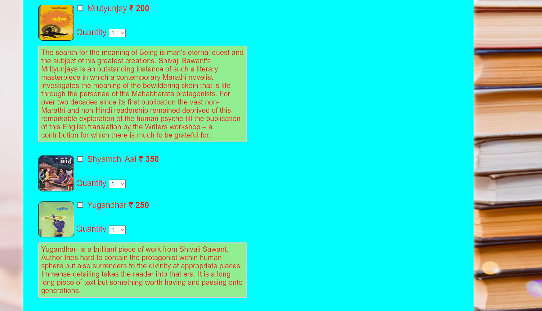

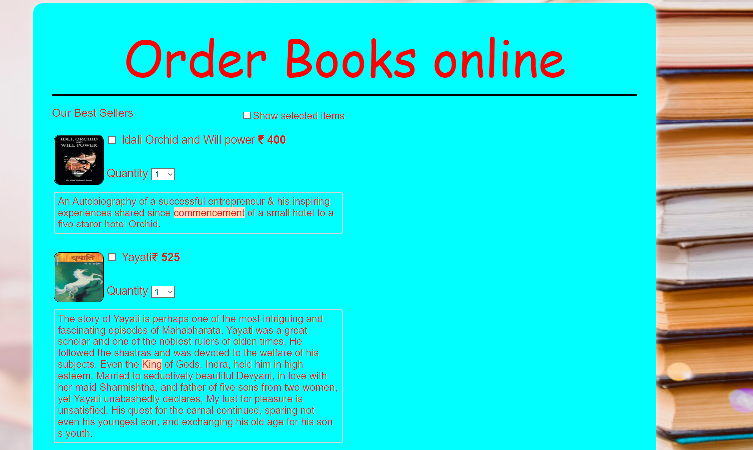

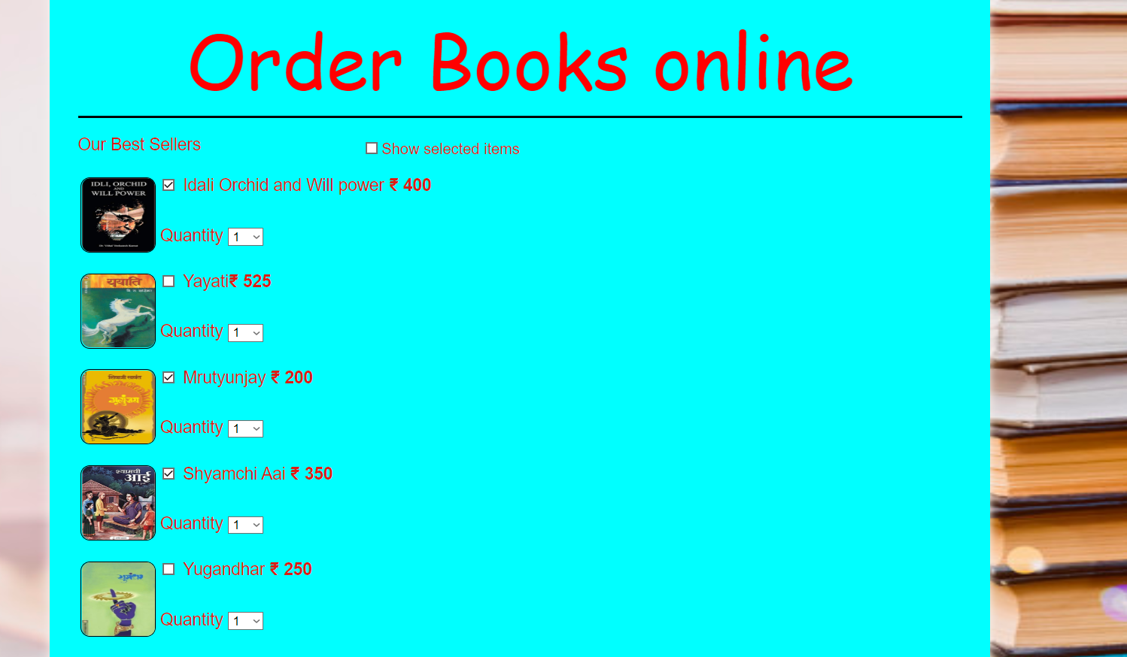

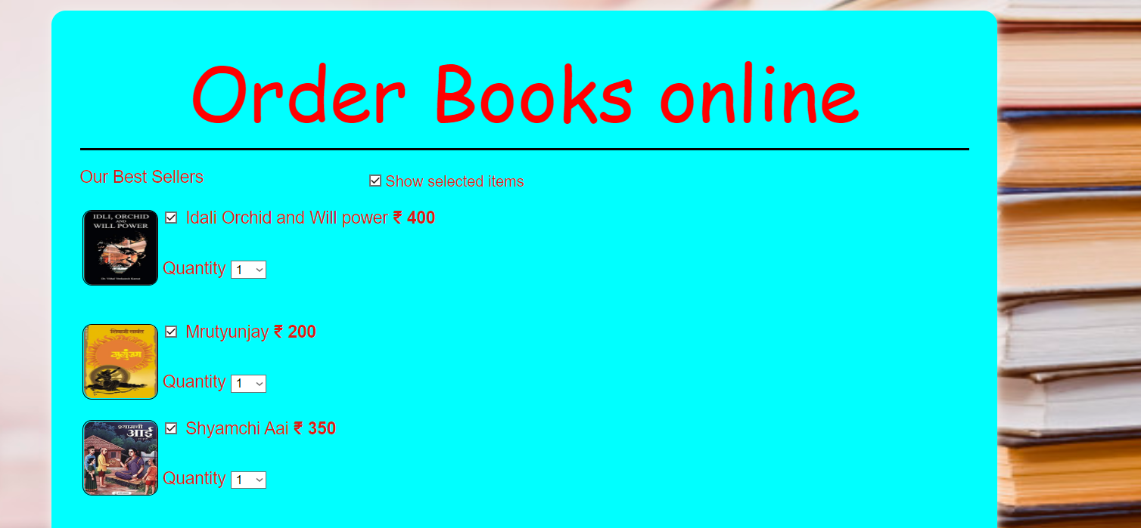



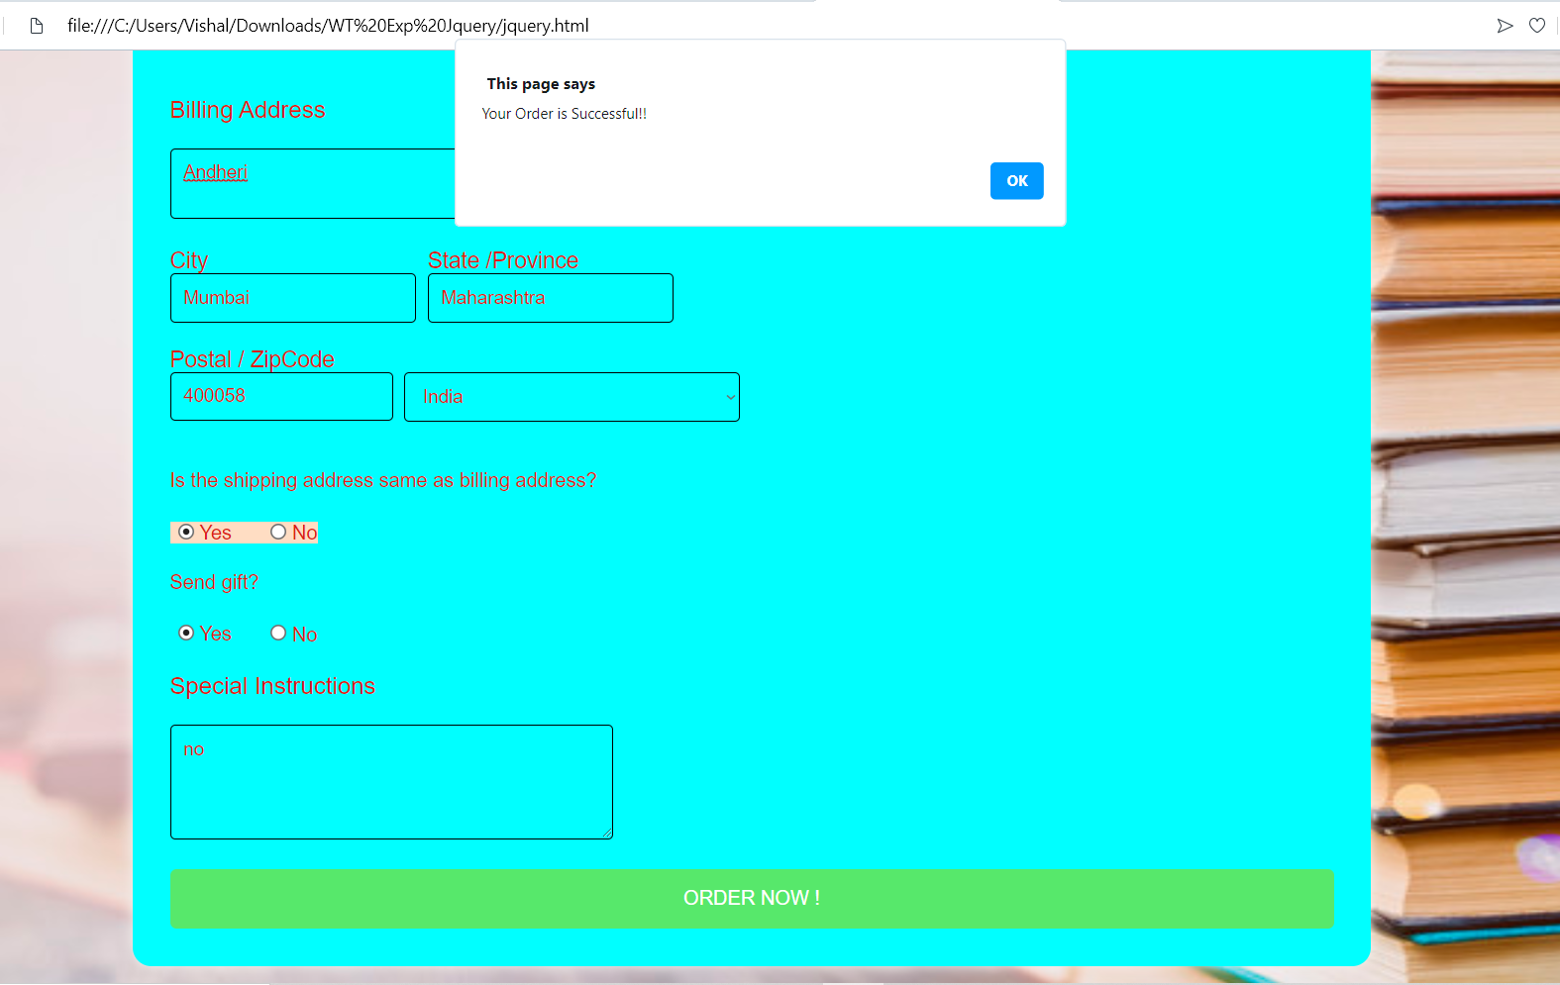

**Conclusion**:

JavaScript closures are a powerful language feature. They are often quite useful in hiding variables from other code, so that we don’t tread on variable names being used elsewhere. Due to jQuery’s frequent reliance on functions as method arguments, they can also be inadvertently created quite often. Understanding them allows us to write more efficient and concise code, and with a bit of care and the use of jQuery’s built-in safeguards we can avoid the memory-related pitfalls they can introduce.